CHAPTER 1
INTRODUCTION
1.1 Introduction to Computer Graphics
Computer Graphics is concerned with all aspects of producing pictures or images using a computer. The field began humbly almost 50 years ago, with the display of a few lines on a cathode-ray tube (CRT); now, we can create images by computer that are indistinguishable from photographs of real objects. We routinely train pilots with simulated airplanes, generating graphical displays of a virtual environment in real time. Feature-length movies made entirely by computer have been successful, both critically and financially. Massive multiplayer games can involve tens of thousands of concurrent participants.
Perhaps the dominant characteristic of this new millennium is how computer and communication technologies have become dominant forces in our lives. Activities as wide –ranging as filmmaking, publishing, banking and education continue to undergo revolutionary changes as these technologies alter the ways in which we conduct our daily activities. The combination of computers, networks, and the complex human visual system, through computer graphics, has led to new ways of displaying information, seeing virtual worlds, and communicating with people and machines.
The Computer Graphics is one of the most effective and commonly used methods to communicate the processed information to the user. It displays the information in the form of graphics objects such as pictures, charts, graphs and diagram instead of simple text. In computer graphics, pictures or graphics objects are presented as a collection of discrete picture elements called pixels. The pixel is the smallest addressable screen element.
Computer graphics today is largely interactive: The user controls the contents structure, and appearance of objects and their displayed images by using input devices, such as a keyboard, mouse, or touch-sensitive panel on the screen. Computer graphics concerns with the pictorial synthesis of real or imaginary objects from their computer based models, where the related field of image processing treats the converse process, the analysis of scenes, or the reconstruction of models of 2D or 3D objects from their pictures. The image processing can be classified as
- Image enhancement.
- Pattern detection and recognition.
- Scene analysis and computer vision.
The image enhancement deals with the improvement in the image quality by eliminating noise or by increasing image contrast. Pattern detection and recognition deals with the detection and clarification of standard patterns. And finding deviations from these patterns .The optical character recognition (OCR) technology is a practical example for pattern detection & recognition. Scene analysis deals with the recognition and reconstruction of 3D model of scene from several 2D images.

  - Introduction to Blender
Blender is the free and open source 3D creation suite. It supports the entirety of the 3D pipeline—modeling, rigging, animation, simulation, rendering, compositing and motion tracking, even video editing and game creation. Blender's features include 3D modeling, UV unwrapping, texturing, raster graphics editing, rigging and skinning, fluid and smoke simulation, particle simulation, soft body simulation, sculpting, animating, match moving, rendering, motion graphics, video editing and compositing.
Though it is often distributed without extensive example scenes found in some
other programs, the software contains features that are characteristic of
High-end 3D software.
Among its capabilities are:
- Support for a variety of geometric primitives, including polygon meshes, fast subdivisionsurface modeling, Beziercurves, NURBSsurfaces, metaballs, icospheres, multi-res digital sculpting (including dynamic topology, maps baking, remeshing , resymetrize, decimation), outline font, and a new n-gon modeling system called B-mesh.
- Internal render engine with scanline rendering, indirect lighting, and ambient occlusion that can export in a wide variety of formats.
- A path tracer render engine called Cycles, which can take advantage of the GPU for rendering. Cycles supports the Open Shading Language since Blender 2.65.
- Integration with a number of external render engines through plugins.
- Key framed animation tools including inverse kinematics, armature (skeletal), hook, curve and lattice-based deformations, shape animations, non-linear animation, constraints, and vertex weighting.
- Simulation tools for soft body dynamics including mesh collision detection, LBM fluid dynamics, smoke simulation, Bullet rigid body dynamics, and ocean generator with waves.
- A particle system that includes support for particle-based hair.
- Modifiers to apply non-destructive effects.
- Python scripting for tool creation and prototyping, game logic, importing/exporting from other formats, task automation and custom tools. Basic non-linear video/audio editing.
- A fully integrated node-based compositor within the rendering pipeline accelerated with OpenGL. Procedural and node-based textures, as well as texture painting, projective painting, vertex painting, weight painting and dynamic painting.
- Real-time control during physics simulation and rendering. Camera and object tracking.
- Grease Pencil tools for 2D animation within a full 3D pipeline.

User interface
Blender's user interface incorporates the following concepts:
- Editing modes
The two primary modes of work are Object Mode and Edit Mode, which are toggled with the Tab key. Object mode is used to manipulate individual objects as a unit, while Edit mode is used to manipulate the actual object data. For example, Object Mode can be used to move, scale, and rotate entire polygon meshes, and Edit Mode can be used to manipulate the individual vertices of a single mesh. There are also several other modes, such as Vertex Paint, Weight Paint, and Sculpt Mode.

- Hotkey usage
Most of the commands are accessible via hotkeys. There are also comprehensive GUI menus.

- Numeric input
Numeric buttons can be "dragged" to change their value directly without the need to aim at a particular widget, as well as being set using the keyboard. Both sliders and number buttons can be constrained to various step sizes with modifiers like the Ctrl and Shift keys. Python expressions can also be typed directly into number entry fields, allowing mathematical expressions to specify values.

- Workspace management
The Blender GUI builds its own tiled windowing system on top of one or multiple windows provided by the underlying platform. One platform window (often sized to fill the screen) is divided into sections and subsections that can be of any type of Blender's views or window-types. The user can define multiple layouts of such Blender windows, called screens, and switch quickly between them by selecting from a menu or with keyboard shortcuts. Each window-type's own GUI elements can be controlled with the same tools that manipulate 3D view. For example, one can zoom in and out of GUI-buttons using similar controls one zooms in and out in the 3D viewport. The GUI viewport and screen layout is fully user-customizable. It is possible to set up the interface for specific tasks such as video editing or UV mapping or texturing by hiding features not used for the task.dividual objects as a unit, while Edit mode is used to manipulate the actual object data. For example, Object Mode can be used to move, scale, and rotate entire polygon meshes, and Edit Mode can be used to manipulate the individual vertices of a single mesh. There are also several other modes, such as Vertex Paint, Weight Paint, and Sculpt Mode.

Supported platforms
Blender is available for Windows Vista and above, Mac OS X 10.6 and above, and Linux. Blender 2.76b is the last supported release for Windows XP and version 2.63 was the last supported release for PowerPC.

File format
Blender features an internal file system that can pack multiple scenes into a single file (called a ".blend" file).

Rendering and ray tracing
Cycles are the path-tracing render engine that is designed to be interactive and easy to use, while still supporting many production features. It comes installed as an add-on that is available by default and can be activated in the top header.

GPU rendering
Cycles supports GPU rendering which is used to help speed up rendering times. There are two GPU rendering modes: CUDA, which is the preferred method for NVIDIA graphics cards; and OpenGL, which supports rendering on AMD graphics cards. Multiple GPUs are also supported, which can be used to create a render farm – although having multiple GPUs doesn't increase the available memory because each GPU can only access its own memory.

1.2.1 Problem Statement
3D Modelling of Handgun. This project depicts about Modelling of Handgun. Handgun is modeled using Reference Image of the Handgun, texture mapping with colors, which makes the Handgun to look very realistic.

1.2.2 Scope
The different concepts used in this project such as Scaling, Rotation, Translation, Extrude, Subdivision Surface & Smooth Shading, effects like Edge Splitting which is used to look Handgun as realistic one .

CHAPTER 2
LITERATURE SURVEY
Existing method:
The simple scene along with the background containing some of the 2D objects (in industry scene) with interaction was existing earlier. Basic OpenGL primitives like GL_POLYGON, GL_TRIANGLES_FANS, GL_QUADS, GL_POINTS etc, are used where we can visualize only one view of the 2D scene that is front view, which is not that useful in the current technology which is being upgraded every now and then. And the 3D Transformation
Proposed technique:
Using Blender, we can model the objects with minimal effort and can maximize the quality, the textures, the various transformations used for viewing the Handgun, which appears so real. The same Handgun which when modeled by OpenGL lacks quality.

CHAPTER 3
REQUIREMENT SPECIFICATION

3.1 Project Requirements
The tool is designed such that users with a computer having minimum configuration can also use it. It does not require complex graphics packages or complex setup procedures.
The tool requires simple installation by downloading it from any website.

3.2 Hardware Requirements
The hardware requirements are very minimal and the software can run on most of the machines.
- Processor – Intel core i5 processor or above.
- Processor Speed - 500 MHz or above
- RAM – 8GB or above
- Storage Space – 1TB or above.
- Monitor resolution - A color monitor with a minimum resolution of 1965*800

3.3 Software Requirements
- A Linux or windows based operating system is required to develop the 2D and 3D graphics applications.
- Blender tool is required to be installed. We used 2.79b Blender Version.

CHAPTER 4
DESIGN
4.1 MODELLING
We used Image of Handgun as Reference to create model.
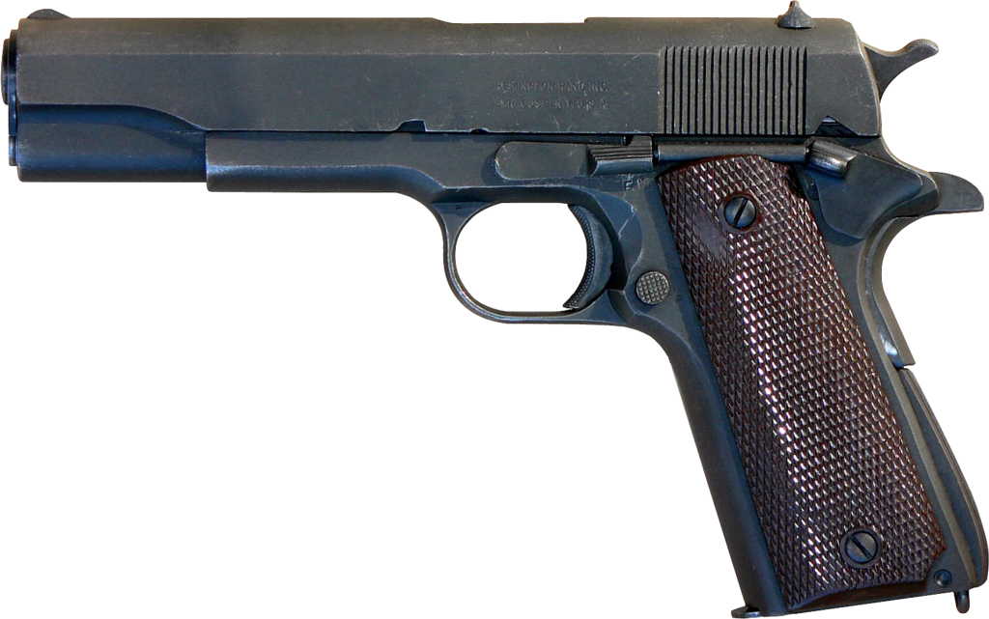

Fig 3.1 Reference Image for Modelling

- To make grip and slide of Handgun, We used the plane. The plane is scaled, rotated and extruded made as per the shape. Then points of the plane is extruded along y-axis which will be looking like a solid surface of grip and slide. Then the surface is subdivided using subdivision surface modifier. Then smoothening and detailing is done and then used edge splitting modifier to look like realistic object.
- To make trigger guard of Handgun, We used the circle. The circle is scaled, rotated and extruded made as per the shape. Then points of the circle is extruded along y-axis which will be looking like a solid surface of trigger guard. Then the surface is subdivided using subdivision surface modifier. Then smoothening and detailing is done and then used edge splitting modifier to look like realistic object.
- To make muzzle part of Handgun, We used the cylinder. The cylinder is scaled, rotated and extruded made as per the shape. Then points of the cylinder is extruded along y-axis which will be looking like a solid surface of muzzle. We removed the front face of the cylinder to have a hole in muzzle. Then the surface is subdivided using subdivision surface modifier. Then smoothening and detailing is done and then used edge splitting modifier to look like realistic object.
- Then other parts of Handgun is done based on above steps. All the parts are combined together in order to look like a gun. Then we added Texture for Handgun in order to look more realistic.
- Then we rendered our model and we will obtain 3D model of Handgun in a more realistic manner.

CHAPTER 5
IMPLEMENTATION

5.1 Blender Functions
- Scaling
This function is used to scale the object i.e to provide it with the perfect size.
- Shade Object
This function is used to provide us with the different views that the model can be seen with while we are seeing a 3D view.
- Material Function
This function is used to display the types of active data and display them. Using this function, we can even edit the data.
- Lighting Function
This function is used to provide the object with proper lighting so that the view of the object is realistic.
- Rotation
This function is used to provide rotation for the object i.e rotate in any axis (x,y,z)
- Rendering
This function is used for rendering i.e. give a realistic view to the object.

CHAPTER 6
RESULTS

6.1 SCREENSHOTS

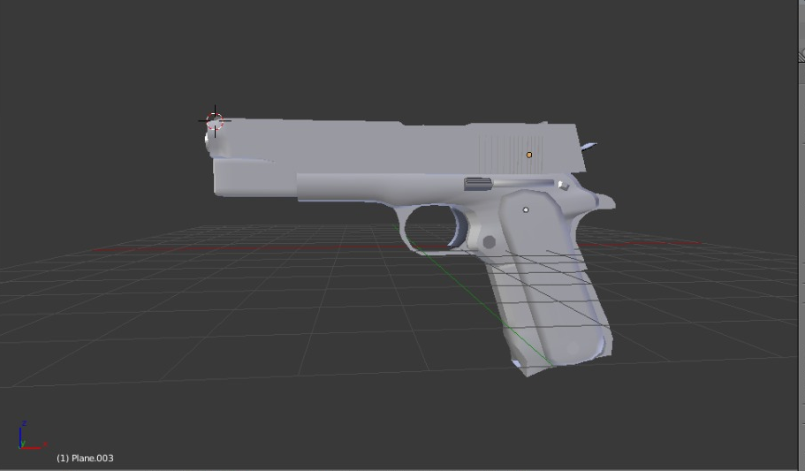
Fig 5.1.1 3D Viewing of Handgun in Solid Form
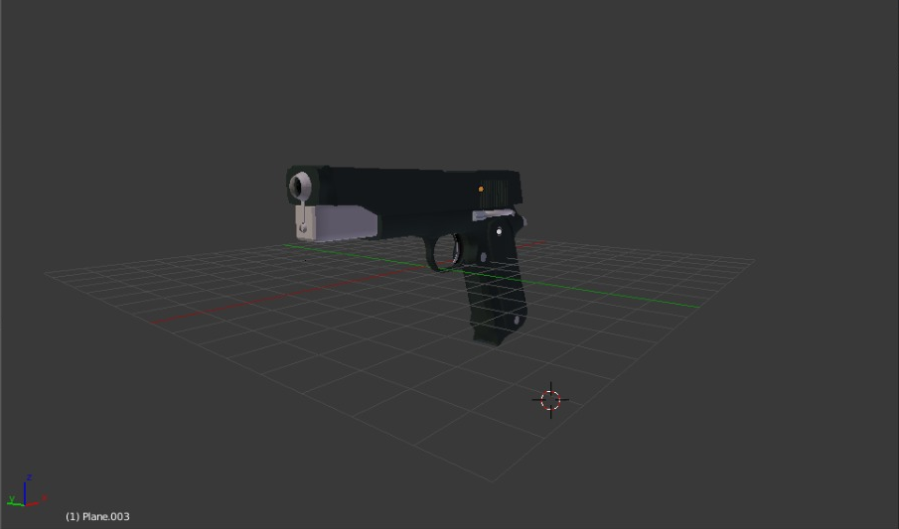

Fig 5.1.2 3D Viewing of Handgun in Textured Form

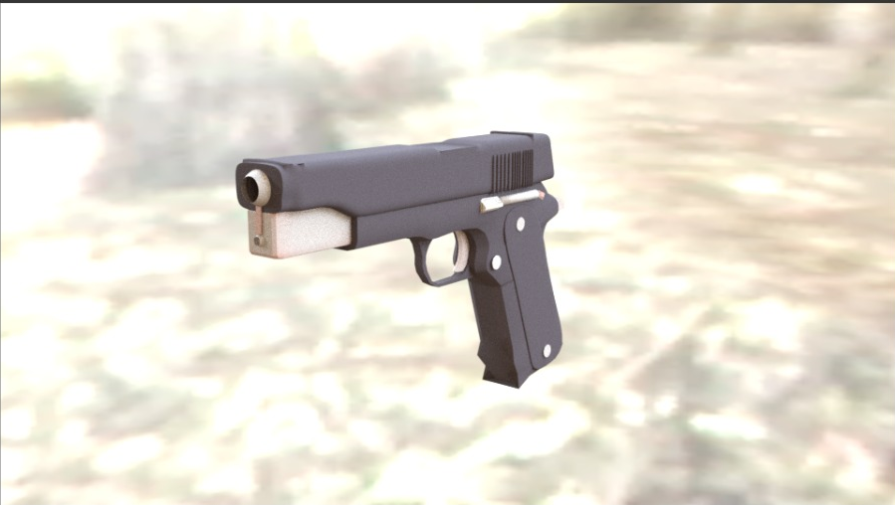

Fig 5.1.3 3D Viewing of Handgun in Rendered Form (Final Output)

CHAPTER 7
CONCLUSION & FUTURE ENHANCEMENT

In this project, we demonstrated the 3D Modelling of Handgun using blender. Using blender for graphics is an advancement as it really produces a more realistic image. The Handgun here looks more realistic as we have applied texture mapping to the model. In future, we implement animation of bullet firing from the gun, applying light sources to different parts. Instead of 2D primitives, 3D primitives can be used for background objects.

REFERENCES

Referred Books

1. Interactive Computer Graphics A Top-Down Approach with OpenGL -Edward Angel, 5th Edition, Addison-Wesley, 2008.

2. James D Foley, Andries Van Dam, Steven K Feiner, John F Hughes, Computer Graphics, Pearson Education 1997.

Websites and Links Referred

1. https://www.blender.org

2. https://www.youtube.com/watch?v=zdzHaaZtCtc
3. https://www.youtube.com/watch?v=yeSxHSPLewI

